Project Sprint #2

The Solitaire game is described in CS449HomeworkOverview.docx. You should read the description very carefully.

Your submission must include the GitHub link to your project, and you must ensure that the instructor has the proper access to your project. You will receive no points otherwise.

GitHub link:
https://github.com/Charles-oak/cs449-peg-solitaire

In this assignment, you aim to implement the minimum features including choosing the board size and type, starting a new game, making a move, determining if a game is over. The following is a sample GUI layout.

The implementation of a GUI is required. You should make every attempt to make your code easy to extend. It is required to separate the user interface code and the game logic code into different classes (refer to the TicTacToe example). xUnit tests are required.

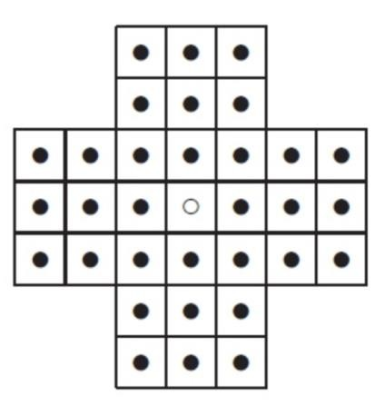

Board size

Board Type

English

Hexagon

Diamond

New Game

7

Figure 1. Sample GUI layout of the Sprint 2 program

Deliverables:

Demonstration (8 points)

Submit a link to a video of no more than three minutes, clearly demonstrating that you have implemented the required features and written some automated unit tests. In the video, you must explain what is being demonstrated. No points will be given without a video link.
YouTube/Panopto link: https://youtu.be/yxhVsAW3wB4

 | Feature
1 | Choose board size and type
2 | Start a new game of the chosen board size and type
3 | Making a move
4 | Checking the end of game
5 | Automated unit tests

Summary of Source Code (1 points)

Source code file name | Production code or test code? | # lines of code
move_validator.py | Production code | 42
solitaire_game.py | Production code | 127
solitaire_gui.py | Production code | 241
test_move_validator.py | Test code | 51
test_solitaire_game.py | Test code | 187
 | Total | 648

You must submit all source code to get any credit for this assignment.

Production Code vs User stories/Acceptance Criteria (3 points)

Update your user stories and acceptance criteria from the previous assignment (if required) and ensure they adequately capture the requirements. Summarize how each of the following user story/acceptance criteria is implemented in your production code (class name and method name etc.). If you are not using an OOP, then adapt the tables accordingly.

User Story ID | User Story
1 | Choose board size and type
2 | Start a new game of the chosen board size and type
3 | Making a move
4 | Checking the end of game

1: Choose size/type | 1.1 | SolitaireGame, SolitaireGUI | validate_size, new_game | Complete | Valid size persists
1: Choose size/type | 1.2 | SolitaireGame, SolitaireGUI | validate_size, new_game | Complete | Invalid size preserves prior settings
1: Choose size/type | 1.3 | SolitaireGame, SolitaireGUI | validate_type, new_game | Complete | English / Hexagon / Diamond
1: Choose size/type | 1.4 | SolitaireGame, SolitaireGUI | new_game | Complete | Latest selected type used
2: Start game | 2.1 | SolitaireGame, SolitaireGUI | board_positions, new_game, draw_board | Complete | Empty center; filled playable cells
2: Start game | 2.2 | SolitaireGame, SolitaireGUI | new_game | Complete | Resets move count and pegs
3: Make move | 3.1 | MoveValidator, SolitaireGame, SolitaireGUI | is_valid_move, make_move, on_board_click | Complete | Horizontal/vertical
3: Make move | 3.2 | MoveValidator, SolitaireGame | is_valid_move, make_move | Complete | Diagonal
3: Make move | 3.3 | MoveValidator, SolitaireGame | is_valid_move, make_move | Complete | Invalid board state
3: Make move | 3.4 | MoveValidator, SolitaireGame | get_middle_position, make_move | Complete | Wrong distance / outside
4: Game over | 4.1 | SolitaireGame, SolitaireGUI | is_game_over, final_rating, on_board_click | Complete | One peg = Outstanding
4: Game over | 4.2 | SolitaireGame, SolitaireGUI | legal_moves, is_game_over, final_rating | Complete | 2/3/4+ peg ratings

Tests vs User stories/Acceptance Criteria (3 points)

Summarize how each of the user story/acceptance criteria is tested by your test code (class name and method name) or manually performed tests.

User Story ID | User Story
1 | Choose board size and type
2 | Start a new game of the chosen board size and type
3 | Making a move
4 | Checking the end of game

4.1 Automated tests directly corresponding to the acceptance criteria of the above user stories
You are required to use ChatGPT to create at least 2 unit tests. You also need to ensure that the generated test cases are correct and refine them if not. At the end of the submission, provide the screenshots of your ChatGPT prompts and answers, along with errors ChatGPT made and you fixed. You may also use another LLM, including hosted locally. Points will be deducted if no screenshots are provided.

User Story ID and Name | Acceptance  Criterion ID | Class Name (s) of the Test Code | Method Name(s) of the Test Code | Status (Pass/Fail/In  Progress)
1 / Choose size&type | 1.1 | TestConfiguration | test_supported_sizes | Pass
1 / Choose size&type | 1.2 | TestConfiguration | test_invalid_size_preserves_selected_configuration | Pass
1 / Choose size&type | 1.3 | TestConfiguration | test_select_each_board_type | Pass
1 / Choose size&type | 1.4 | TestConfiguration | test_change_type_only_new_type_kept | Pass
2 / Start new game | 2.1 | TestInitialization | test_center_empty_and_other_cells_filled | Pass
2 / Start new game | 2.2 | TestInitialization | test_restart_resets_moves_and_board | Pass
3 / Make move | 3.1 | TestMove | test_vertical_jump_updates_three_cells_and_count | Pass
3 / Make move | 3.2 | TestMove | test_diagonal_jump | Pass
3 / Make move | 3.3 | TestMove | test_reject_occupied_destination | Pass
3 / Make move | 3.4 | TestMove | test_reject_wrong_distance | Pass
4 / Game over | 4.1 | TestEndOfGame | test_one_peg_outstanding | Pass
4 / Game over | 4.2 | TestEndOfGame | test_no_moves_two_pegs_very_good | Pass

4.2 Manual tests directly corresponding to the acceptance criteria of the above user stories (if any)

User Story ID and Name | Acceptance  Criterion ID | Test Case Input | Test Oracle  (Expected Output) | Notes
1 | 1.1 / 1.3 | Select size 9, type Diamond, New game | Diamond layout of size 9 is drawn; model settings updated | Passed (as reported)
1 | 1.2 | After size 9, enter 8 and New game | Error displayed; size returns to 9; old board unchanged | Passed (as reported)
2 | 2.1 / 2.2 | Start/restart English 7 | Empty center, 32 pegs, 0 moves | Passed (as reported)
3 | 3.1 | Click (3,1), then center (3,3) | 31 pegs, 1 move; board cells updated | Passed (as reported)

4.3 Other automated or manual tests not corresponding to the acceptance criteria of the above user stories (if any)

Number | Test Input | Expected Result | Class Name of the Test Code | Method Name of the Test Code
1 | Invalid board size string / bool | ValueError; size remains 7 | TestConfiguration | test_invalid_size_text_and_bool
2 | More end-state ratings | Good / Average | TestEndOfGame | test_no_moves_three_pegs_good; test_no_moves_four_pegs_average

5. LLM Unit Test Evidence

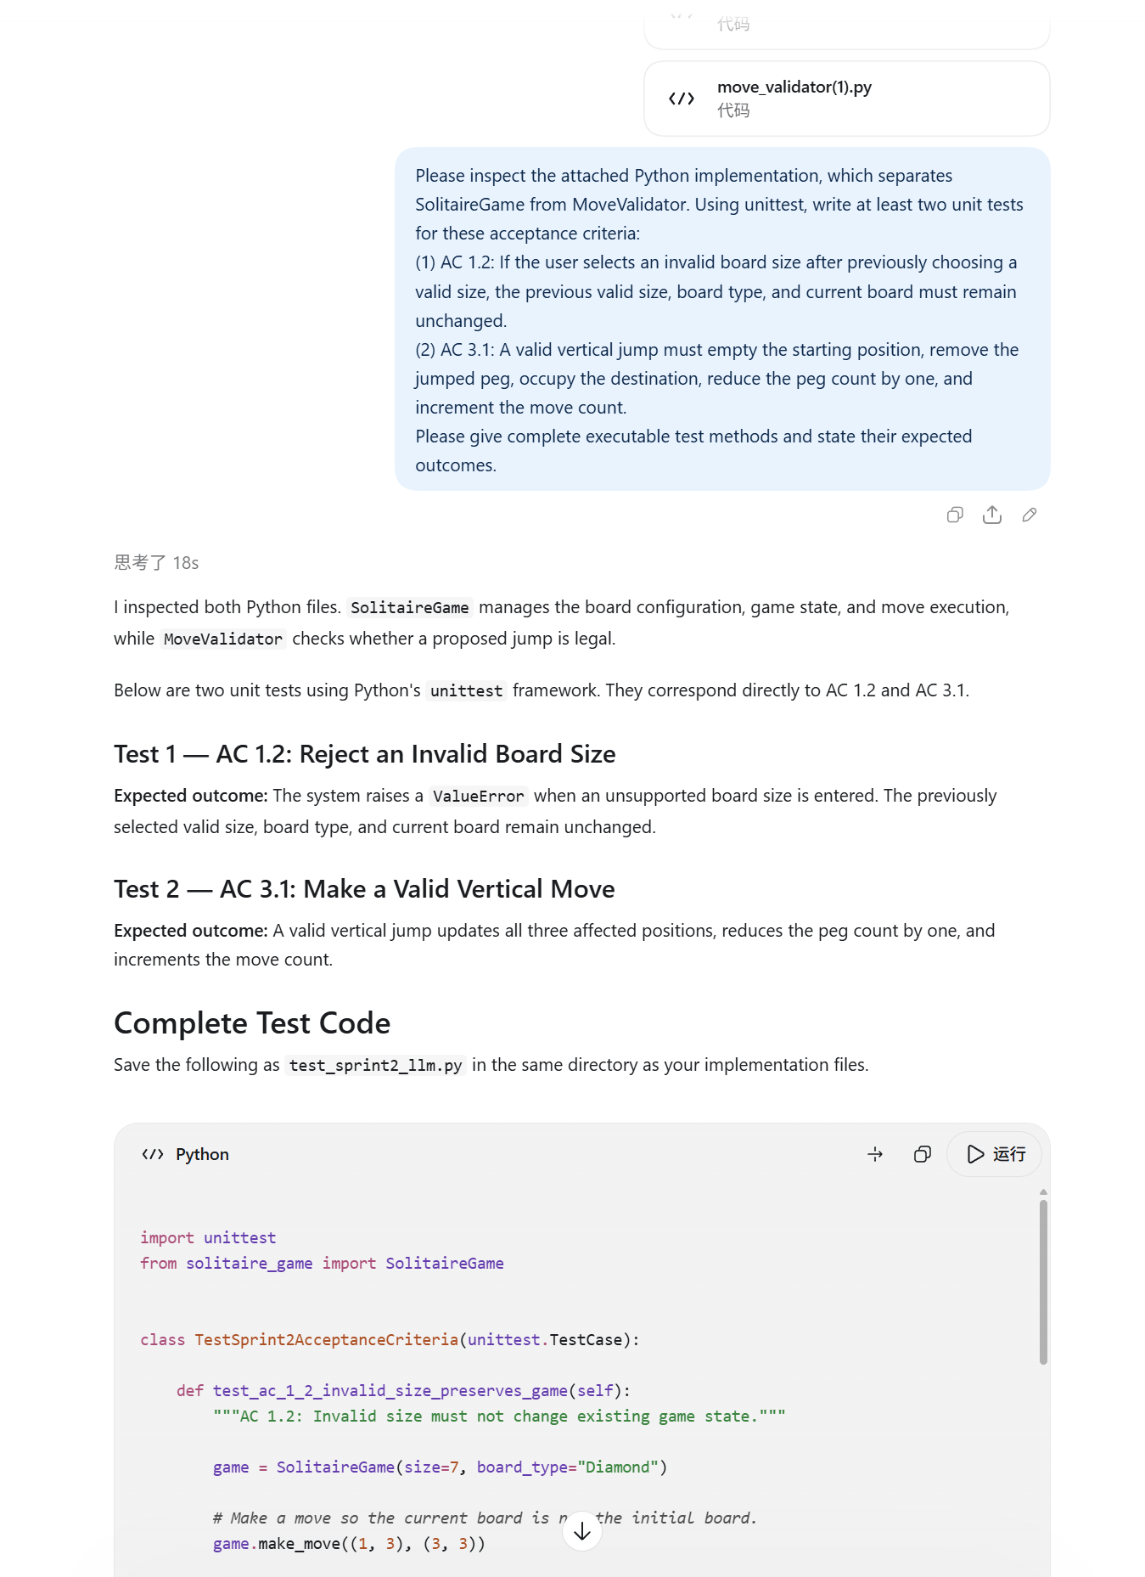
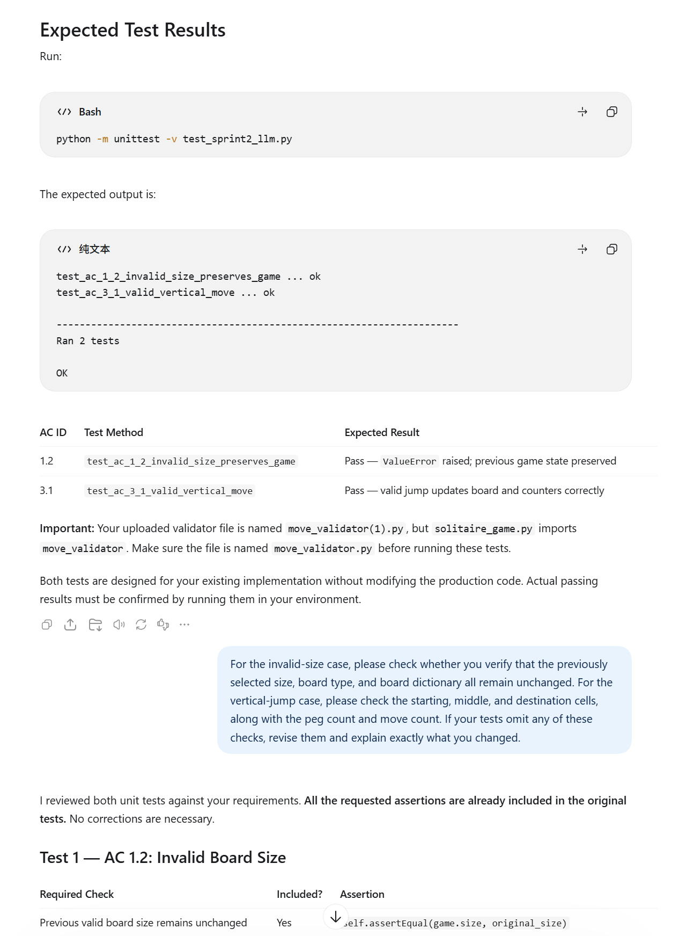
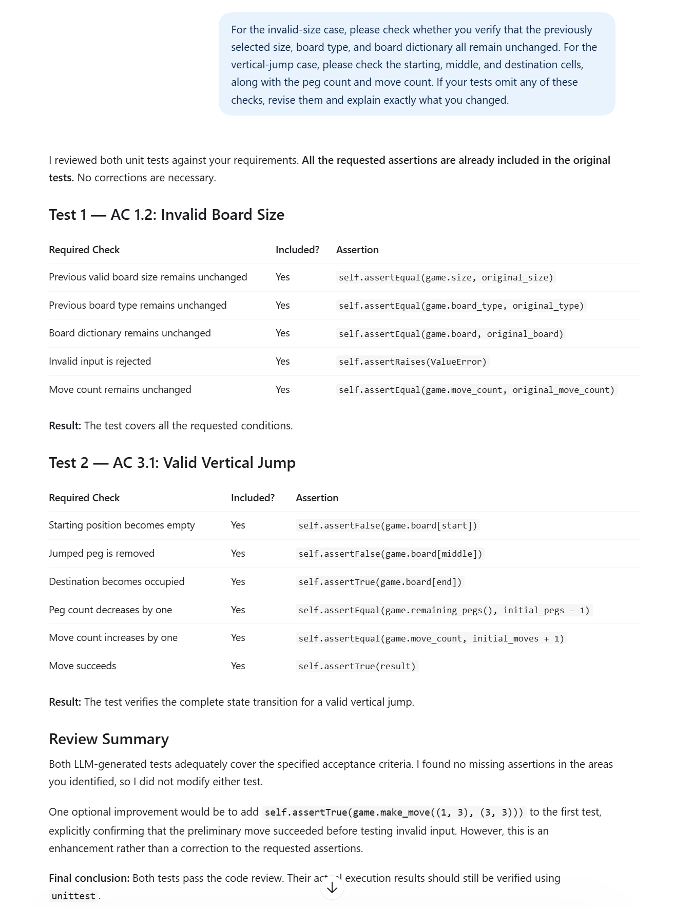

Submission Guidelines:
Each student must independently upload LastName_FirstName_Sprint2.docx to Canvas. Include:
- Your name
- GitHub repository link containing all production code and automated tests. Ensure that the link is public.
- Demonstration video link — a narrated video of no more than 3 minutes showing the required features and automated tests (again the link should be public).
- Source-code summary table — filenames, production/test classification, line counts, and total.
- Updated user stories and acceptance criteria, mapped to implementation classes and methods, with completion status.
- Testing tables — automated test mappings and results, plus manual or additional tests where applicable.
- LLM evidence — screenshots of prompts and responses used to generate at least two unit tests, with an explanation of how you checked them and corrected any errors.
Mark unused optional sections “Not applicable.” Before submitting, verify that the instructor can access your GitHub repository and video.

